Library Framework
Chapter
8
This Library Framework package provides services for organizing groups of abstract libraries and library entries. It is common in engineering applications to have the need to reference standard items such as parts (standard girders), rules (Specifications), and materials (standard concrete). Hence, it is useful to be able to store these entries in a library file which spans all project files. This enables the ability to reuse data which speeds up the data entry process and makes it less error prone.

LibraryFw
The Unit Library service provides a mechanism for storing and retrieving abstract named entries. The core code of this service is in the form of templates, allowing it to be used for any type of entry.

Requirements
The unit library must:
- Allow users to store any type of data they might want to store
- Provide stream-based persistent storage
- Supply a level of unit consistence throughout all entries

Logical Design
A static view of the Library Framework classes is shown in Figure 1. The top-most class in the framework is the libLibraryManager which contains and manages access to libILibraries. LibILibrary is a pure abstract interface class which describes the services required by libLibraryManager. This allows users the flexibility to choose whether or not they want to use libLibrary for their library class and allows template classes to be placed into the manager. LibLibrary is a template class which can be instantiated to store a collection of a given entry type. Libraries can only contain a single type of entry.
LibLibraryEntry is an abstract helper class which supports most of the services required by libLibrary except for the entry editing user interface code and routines for storing and loading entry data. This gives users who want to create new types of entries a good head start at an implementation.

Static Models
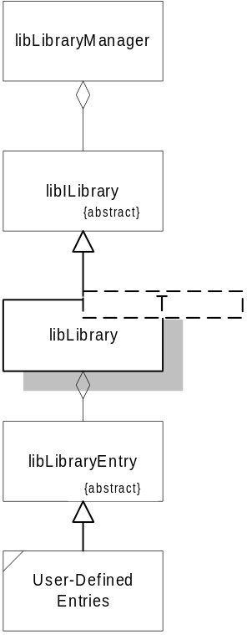
Figure 1

Dynamic Models

Physical Design

Specifications

